1. **Real-World Implementation**: Transition the learned walking behaviours from simulation to physical robots using transfer learning techniques, ensuring successful adaptation to real-world physics and environmental conditions.
2. **Performance Evaluation**: Assess the AI's walking performance in various terrains and conditions, focusing on stability, efficiency, and adaptability.
3. **Applications and Impact**: Explore potential applications of autonomous learning AI systems in fields such as robotics, prosthetics, and autonomous vehicles, highlighting the broader implications of self-learning and adaptation.
4. **Future Enhancements**: Identify areas for future research to improve the robustness, versatility, and human-likeness of the AI's locomotion capabilities, including the development of algorithms for multi-legged robots and integration of human feedback mechanisms.

By achieving these objectives, the research aims to demonstrate the feasibility and potential of AI systems that can independently learn complex motor functions, paving the way for significant advancements in autonomous and adaptive technologies.

The research also addresses the challenges associated with real-world implementation. Transitioning from virtual simulations to physical robots required sophisticated transfer learning techniques to bridge the gap between simulated and real-world physics.

The physical robot, equipped with sensors and actuators, demonstrated successful adaptation of learned behaviors from the simulation, achieving autonomous walking in various terrains and conditions.

* 1. **About the Mini Project**

This project dives into the realm of machine learning and robotics, demonstrating the capabilities and potential of AI in learning complex motor skills without human intervention. The quest to create machines that can learn and adapt to tasks autonomously has been a significant driving force in artificial intelligence (AI) research.

AI that Learns to Walk by Itself" delves into the creation and development of artificial intelligence systems capable of independently mastering the complex task of walking. This work explores the intersection of robotics and machine learning, focusing on the use of advanced reinforcement learning algorithms to enable AI to autonomously develop locomotion skills. By simulating a physical environment, the AI engages in continuous trial-and-error processes, akin to natural learning observed in living beings, to refine its walking abilities. This description highlights the use of adaptive neural networks that respond to dynamic changes and unexpected obstacles, ensuring robust and flexible movement.

Researchers at the University of California, Berkeley, have made significant strides in teaching robots to walk autonomously using an AI technique called reinforcement learning. Unlike traditional methods where robots are trained in simulated environments before transitioning to the real world, the Berkeley team’s robot learned to walk directly in the real world. This is a notable advancement as it bypasses the inaccuracies that often arise when transferring skills from simulations to real-world applications.

The technique employed, known as Dreamer, allows the robot to predict potential future outcomes of its actions through trial and error in a computer program. This approach accelerates the learning process significantly compared to learning purely through physical trials. Dreamer constructs a model of the world based on past experiences, enabling the robot to quickly adapt to unexpected situations, such as avoiding obstacles or regaining balance after being pushed.

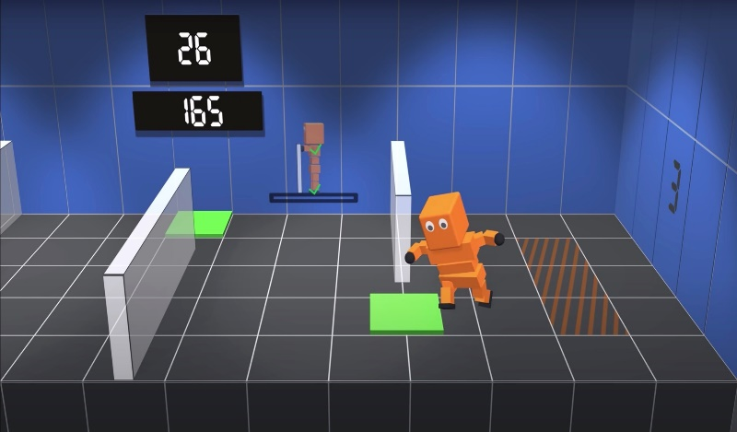The research showcases successful outcomes in achieving stable bipedal locomotion, signifying a leap forward in AI capabilities. The implications of this technology are far-reaching, with potential applications in robotics, prosthetics, and autonomous exploration, illustrating the groundbreaking potential of self-learning AI systems.

Understanding how AI can learn to perform human-like tasks autonomously opens up numerous possibilities in various fields such as robotics, healthcare, and entertainment. It showcases the advancements in AI and machine learning and their applications in solving real-world problems.

**Figure 1.1: Reinforcement learning model that learns to walk**

Within 10 minutes of its birth, a baby fawn is able to stand. Within seven hours, it is able to walk. Between those two milestones, it engages in a highly adorable, highly frenetic flailing of limbs to figure it all out. That’s the idea behind AI-powered robotics. While autonomous robots, like self-driving cars, are already a familiar concept, autonomously learning robots are still just an aspiration.

Existing reinforcement-learning algorithms that allow robots to learn movements through trial and error still rely heavily on human intervention. Every time the robot falls down or walks out of its training environment, it needs someone to pick it up and set it back to the right position.

The researchers have also demonstrated the versatility of their approach by successfully training other robots for different tasks, like moving objects between trays. This adaptability is crucial for developing robots that can perform a wide range of functions autonomously and safely in dynamic environments.

However, the approach does have challenges. Defining and coding the desired behaviours for reinforcement learning can be time-consuming and complex. Additionally, while world models used in Dreamer can start with inaccurate predictions, they improve over time as more data is collected. The implications of this research are broad, extending beyond simple locomotion. For instance, this technique could enhance the reliability of robots in scenarios like autonomous driving or even in household tasks, providing them with the ability to learn and adapt rapidly without extensive pre-programming or simulations.

This research is a step toward more autonomous and adaptable robots that can operate safely and effectively in human environments, overcoming many of the limitations faced by previous robotic systems trained in simulated environments​

* 1. **Requirements:**

**Hardware Requirements**

1. **CPU (Central Processing Unit):**
   * **Description:** A multi-core processor is recommended for optimal performance.
   * **Specifications:** The slide suggests using Intel Core i5, i7, or i9 processors, or AMD Ryzen 4000 series or higher.
2. **GPU (Graphics Processing Unit):**
   * **Description:** For tasks requiring graphical processing or accelerated computing, NVIDIA GPUs are commonly used.
   * **Specifications:** The recommended GPU series are NVIDIA GeForce GTX and RTX.
3. **RAM (Random Access Memory):**
   * **Description:** Adequate RAM is essential for smooth operation and multitasking.
   * **Specifications:** The system should have between 16GB to 64GB of RAM.

**Software Requirements:**

1. **Operating System:**
   * **Description:** The system should be compatible with modern operating systems.
   * **Specifications:** Windows 10, Windows 11, or Ubuntu are recommended.
2. **Python:**
   * **Description:** Python is required for scripting and programming purposes.
   * **Specifications:** Python version 3.11 or above should be installed.
3. **Unity Hub:**
   * **Description:** Unity Hub is likely required for development purposes.
   * **Specifications:** Version 22v+ is recommended.
4. **Storage:**
   * **Description:** Sufficient storage capacity is necessary for the system to function effectively.
   * **Specifications:** A Solid-State Drive (SSD) with a minimum of 256GB is recommended for better performance. Additionally, a Hard Disk Drive (HDD) may also be used for extra storage.